***Dhanush kumar.k***

***731621106008***

***KSRIET***

**Exercise-3 :**

1. First, one person in the group should create a public repository using their GitHub account.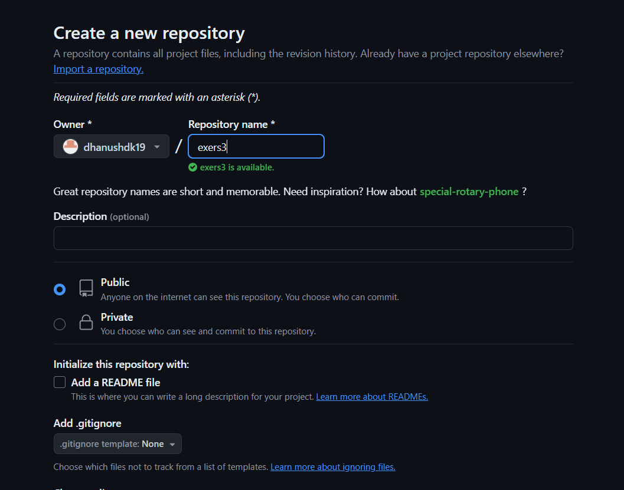

2. This same person should then follow the instructions from GitHub to add a remote, and then push their repository. Do not forget the –u flag, as suggested by GitHub!

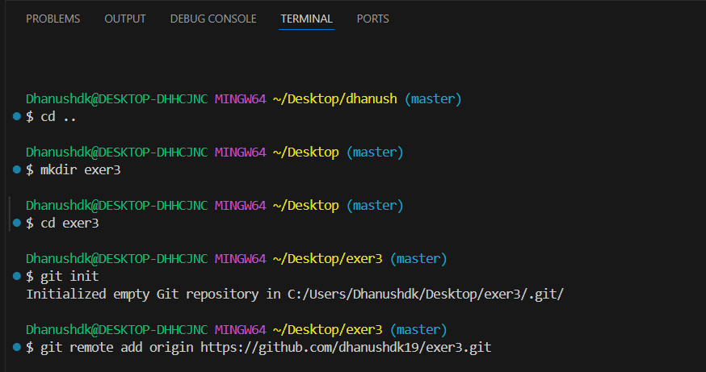

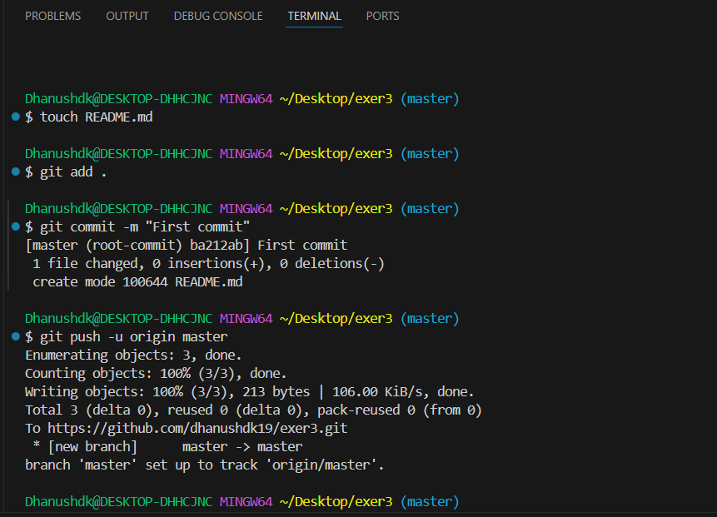

3. All of the other members of the group should then be added as collaborators, so they can commit to the repository also.

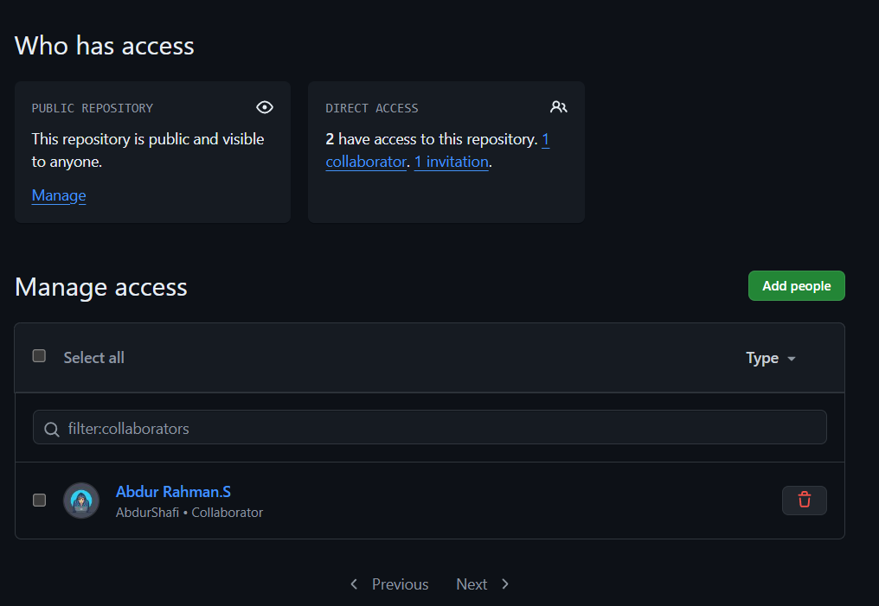

4. Next, everyone else in the group should clone the repository from GitHub. Verify that the context of the repository is what is expected.

5. One of the group members who just cloned should now make a local commit, then push it. Everyone should verify that when they pull, that commit is added to their local repository (use git log to check for it).

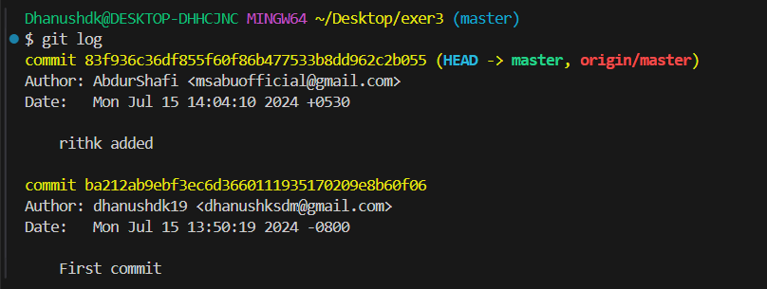

6. Look at each other’s git log output. Notice how the SHA-1 is the same for a given commit across every copy of the repository. Why is this important?

7. Two members of the group should now make a commit locally, and race to push it. To keep things simple, be sure to edit different files. What happens to the runner-up?

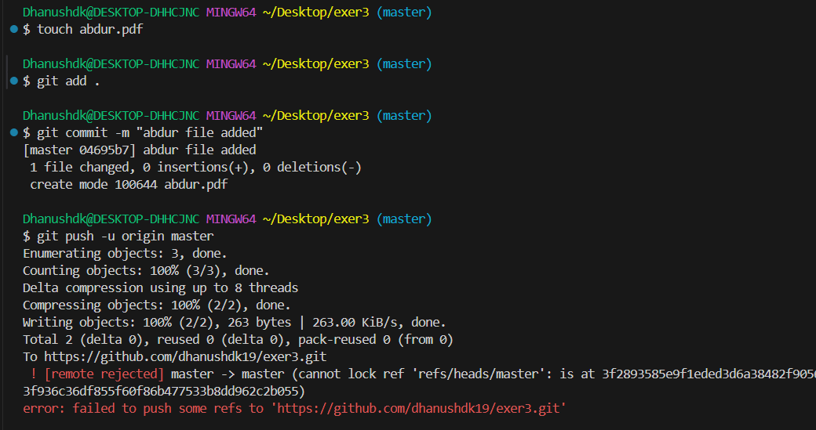

8. The runner-up should now pull. As a group, look at the output of the command. Additionally, look at the git log, and notice that there is a merge commit. You may also wish to view the DAG in gitk.

9. Repeat the last two steps a couple of times, to practice.



